Name: Renee Simpson
Date: January 14, 2011
Warm up TV-Studio

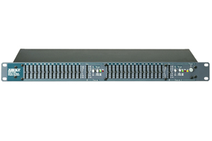
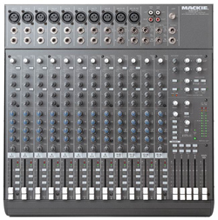
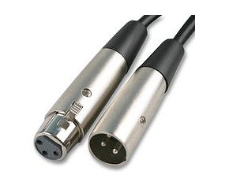
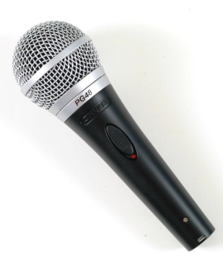
Please show the two main ways a microphone, an equalizer, and a sound board can be connected together. Copy and Paste items as needed

